Thy Kingdom Come sermon series – the millennial reign of our Lord
Part 1, April 11, 2021
https://youtu.be/XpWu9jhTNrg?t=3165
Today’s passage = Acts 1: 1–11.
The plans for our future. He appeared for 40 days (after His Resurrection). He taught disciples in desert for the same time period. He came to establish the Kingdom of God. For the people of God. Christ taught disciples in desert for the same time period. The Kingdom will come to Earth, but a “little problem” is Church’s emphasis – they’ve reversed what goes where. This theme is the focus of Christ’s ministry – the goal. Matt. 4:17. It’s going on now. “Repent, for the Kingdom of God is at hand” – His people – the Church is where His will is done – the Church. He is there. It’s a “beginning manifestation.” The petitionary prayer. Our view is often not right. It makes heaven not real, uninteresting and leads to a love of the world. But we identify with heaven on Earth. That’s what we need to do, to realize. It’s the only plan, the story God has had. It has not changed since Genesis 1. Read it. That’s where we are heading! The Earth was given to Adam to rule over, the sphere. Verse 29 – Commandment = fill and subdue Earth and rule over the creatures. So why overpopulation? – attack on God. Carbon (dioxide) is “us” its’s our wrong idea. The chaos now shows we are not doing well. We are using technology to gain control and then to rule. But that way leads to censoring God (on social media). Revelation shows what happens with that. (Not sure if pastor means this: Is that /does that show liberal church is wrong? They are not the ones who are /will be making the golden age come about!?)

The answer is to bring Man and God together to build the Kingdom = Jesus Christ. Luke 1 has the Great Commission and the Ascension. But Matt. 28:18 has “all authority on heaven and on Earth.” It all comes together – or it will when the millennial reign happens. (Me: only then!)

Its not just about getting forgiven and saved, but to work together to restore Kingdom. We will not just evangelize and then leave the Earth. We stay, and so have to teach “everything
I have commanded.” But what we do/ have done now – some places where God’s will is done, but that result is temporary or incomplete. (It won’t be enough?)
People don’t realize the millennium, which is just the beginning. God can and will take care of the Earth. Thugs will not be the ones to take over the Earth = a disaster, its falling apart. Washington does not know how to do it. We can build, but our power is not one that can build something everlasting. We will and do mess it up. Thus the story in Book of Revelation.
Have you heard those wrong ideas. Trucks? Escape Earth – we can’t save planet, its fate. But preventing global warming is the wrong way.

The disciples understood what Christ meant, but the Church does not. The verse 6 that’s misunderstood: “Lord, is it at this time that you will restore the Kingdome of God to Israel?” And Christ said [pastor’s joke] no, He said …
The state of Israel is the reason and the proof of the battle that we are in; the world says “No!”
The state of the world is not good. That’s what would happen if we have our way, but God says, “The world is going to be restored.” God has not given up on it. We will love the Earth. It will not have bad neighborhoods only have good zones. Jesus will be here. He will use us to do so.
The coming new administration on Earth that replaces the current crummy one. It will have awesome people in it. Rule and reign – is in Rev. 20. A lot of people don’t believe this, or have their own different ideas. But God wants to do something with us. We will begin building it.

Part 2
Today’s passage = Micah 4: 1-5. The Mountain of the Lord will be raised above the hills, and the people of the world will come to it.

We are near to this and it will really happen! A glorious day. The Kingdom will come to pass; we are in the season now. We had a problem that messed up the Kingdom. They were flawed, like us. The Jewish Kingdom fell apart. But the Lord hasn’t given up. We will need new people, something has to change. We are being shaped, growing and becoming more like Him, through the Spirit. Then we will be ready. His redeemed people. The gates of Hell will not prevail against the Lord’s work in our lives. “I will give you the keys to the Kingdom.” Matt. 16:19.
Why – because it is what God wants. Missionary and discipleship are the means through which it’s accomplished. Acts 1:6 Is it at this time? How many of us think it’s about Israel – we think of heaven, or maybe the Garden. That’s where we get in trouble. Like M. Luther did in his commentary, who thought that the language there is figurative, so it means something different than actually dealing with Israel. There was no discussion, the Kingdom wasn’t growing. We still don’t understand what’s coming. Our views can be wrong, so be teachable, remain open to Scripture.
What was that question about? It was about Restoring the Kingdom to Israel – the disciples knew that. It wasn’t about the Church (denominations named). A glorious King in a land of peace, without enemies. It never happened in Israel’s history because they were always fighting. Jesus talked about in it Matt. 12:42. “One greater than Solomon is here. “ Is a prophecy. His millennial picture is like 1 Kings chapter 10 passage about the queen of the South verse 6. Solomon’s wisdom and wealth. How happy the people must be to hear it. Praise! to God’s “eternal love for Israel” for he made you a righteous King. But that town fell apart, it was sacked and leveled. What then about the Promises made to Israel, the Jews asked longingly. God was / would finish it according to his plan, and nothing can stop it. Notice no harps in Micah 4! Heaven is different than the millennial Kingdom. It is coming, but it is not the same thing. We have to distinguish them. We weren’t taught this. We don’t understand and/or pastors don’t want controversy. Amillennialists in this town [true]! Glenn knows (because he was “raised with” the CRC]. We can respect that, but can grow.
He didn’t answer – he said its not for you to know the times or the season. 2,000 years later.
Heaven will be kind of weird. Physically. It will be like a cube, like the Holy of Holies. We want to get in there! It will be open, so we can get in there. Its not the Earth. Rev. 21 is different with Micah 4. That is where the drama is, but they cannot be reconciled.
In the last days, = time is being measured. Compare with eternal state where it won’t be.
The last day is the Sabbath. Jerusalem is the mountain of the Lord. The nations are already and will certainly be coming. Some day. Tourists are fulfilling it. Mark Twain visited there [it was in 1867]. Go and see the Lord. We are a part of the Restoration. We are getting ready for it. Amazing! Jeff loves Israel, and is privileged to watch it happening. He will judge and settle disputes between the nations. Our Lord will be the ruler over them. Wonderful when it happens. Why don’t people talk about this? Matt. 19: 28. Where will my sacrifices mean?
“I tell you the truth. At the renewal of all things, when the Son of Man sits on his glorious throne … everyone will receive a hundred times as much … the last shall be first.” If we didn’t spend any money on defense budgets, then it will be a heaven on Earth – a flourishing like it was during the Renaissance [my term, when they made developments in Arts and Sciences].

Part 3
Today’s passage =Isaiah 65: 17-25.
https://youtu.be/t4qBMkdqef4?t=3309
The Gospel is not just good news about our redemption from our sins. It also implies our future with our Lord in His Kingdom. It is a restoration. Why did the Lord let sin into world? So we understand how bad things will be without Him. We have to be shown that. If everything was always good, then we wouldn’t realize that we cannot rule this world. But we get good reminders of how good, glorious it will be. On the Earth first. We understand what heavenly is/will be. We want the spirit of heaven. We will talk more about Israel … the greatest moment in their history points to this time. What can we do with this question – is it at this time. So you don’t go to the next question. Why doesn’t the Church want to know? Isaiah 65. The Lord is interested in Israel. Genesis 12 [pastor’s joke, then says it’s a prophecy]. We don’t want to leave. Through this the entire earth will be blessed. Gen. 15: 18-19 on that day I give this land.
It’s the whole Middle East. If Israel isn’t restored then God isn’t God. That’s not right. Or the entire world wouldn’t be restored. Then promise / covenant wouldn’t be kept. It is all about his promise. A Passover lamb = future and hope. The Abrahamic covenant. We almost got there once with King Solomon. 1 Kings 4 has the geography – which wasn’t limited. The people were happy. That’s the promise, what all the disciples understood, and it’s a new Garden. How can we be done with this? Notice that it is not fulfilled, so it will still happen. Only God can finish it.
Everything in America is about these issues. We are in the drama for a reason. We are getting very close. God is faithful. It will be finished, fulfilled, all according to His word.

Discussing the passage now, and why we don’t understand it. We don’t really care about it.
The former things will not be remembered nor come to mind. That means all of the chaos, the pain – in Jerusalem. It’s their real history. About 28 wars there. Something amazing is going to happen there, in the center of it all. From bullet holes to a delight and a joy. The Oakhill trip in the year 2000 got crazy – the pizzeria bombing happened. Jeff still went. AntiSemitism is prevalent because, umm so it’s a big contrast? No more weeping. The Lord will be there then, and so will we. Building houses and planting vineyards is in the passage, it will last long enough for that. Evil will be bound, restricted. Note the part at end of passage that says, “dust will be the serpent’s food.” So its connected to the demonic realm. Deception and lies are the tools of that realm. Evil will be controlled. Rev. 20 says same thing, connect the dots. God’s purpose and plan – why can’t we talk about them. Is it just because of politics? NO. It’s to show us what God can and will do. He must. We can’t ignore what’s happening. A World War is coming, like 1914. Suddenly it struck. Stop the world from destroying itself – like in Noah’s day. When they started the world again. They knew what sin does, but also what God’s plan is. God has the power to begin again, to renew. Nothing can stop His plan – for you, me, and everything. No we don’t fully understand it all. Our church history – we were in trouble 20 years ago. We have helped to build a kingdom in our local church. That is a picture of how it will be then. Amazing things are coming, and its in the Bible from 3000 years ago. They helped, and there were groups of 24, in old and New Testament. Those singers and servants were worshipping the Lord. The earth will be filled – Habakkuk. They were a part of His purposes.
That gives us meaningfulness in life (from the prayer).

Part 4.
Today’s passage = Rev. 20: 1-6.
Who is ruling with Christ – us, the Church. Lasting 1000 years.
https://youtu.be/q7QzLB5XAIY?t=2920
We want this world to be changed, to reflect His Kingdom.
Matt. 26:29. We are not going to be celebrating Passover/communion. We will all understand the purpose of the law at that time; its truth and meaning are to point us to Christ. We won’t need the 5 books of Moses = Torah, because it will be on our hearts already. Matt. 5:18.
We only need them Until heaven and Earth disappear (Rev 21 & 22) – which they will do at that time. Until everything is accomplished – the law will be accomplished in our heart. When that happens then ... we will reflect him (His love and grace) and be conformed to his image. Forever. Amazing! Rev. 19 is the second coming, and then the rest of the chapter happens.
Rev. 20. The church sometimes thinks we can’t be too literal (with this text). We need to idealize the passage, it’s a picture of something in the future … ,there is no millennium.
Does it make sense – then take it at face value, don’t shift its understanding – it might not remain faithful to Scripture’s real meaning. Like many, many people have done. We can understand this! God wants us to understand it. It’s a love letter from God to us. He doesn’t want us to have all the drama, its an anchor. Then we will have peace. Those [amillennialists] are getting nervous. We don’t need to be nervous about whats happening. “Because He lives” we can teach this to our children. Acts 1:6. Micah 4 and Isaiah 65 – a recap, they are about Rev. 20:4 (Them is us – write “me”). The Holy Spirit will help us connect the dots. It’s got to be a personal thing. That’s how you get the blessing promised in Rev. Rule and reign!

The pastor gave 4 passages to pray over = Matt 26: 19. Matt. 19:28 = “At the renewal of all things, and you who have followed me will also ….” = Rev. 4. Many Christians don’t …
Second verse Luke 22:29-30. Its not a fringe thing/thinking! And I confer upon you a Kingdom, just as my Father did …
Matt. 20: 20-23 will James and John brothers be on the right and left of the throne and the coming Kingdom- its on Earth, not the new Jerusalem = heaven.
1 Cor. 6:2 “Do you not know, the saints will judge the world,” not the other way around.
Its all going to change at the end.
Could be a hundred more verses. Methuselah. 969 < 1000 years. Bring glory and honor.
Practical applications here and now. Godly = what we pray for is coming. A new administration/government here in history – it has never happened in world history YET and we will live to see it happen … anguish and drama will end – in Jerusalem. Why are we saying this. Promises will be kept. The OT ones to Israel and the Fathers. Fruitful and multiply. Jerusalem will flourish. We will see the beauty of this world. We haven’t seen it of the whole world, we need to travel and know more of it. Finally the expanded Kingdom is a greater number/amount/population. He is not done here. These things are coming. Amazing!

Handouts from class:
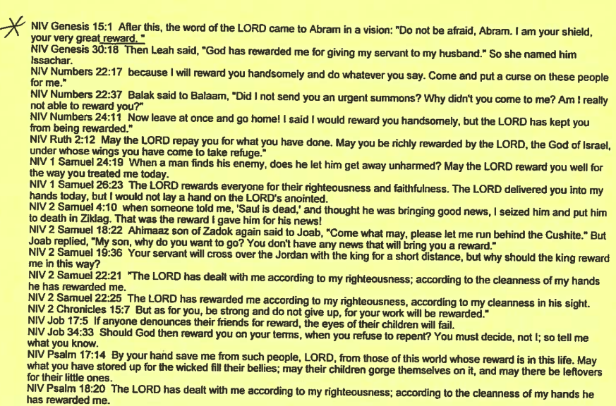
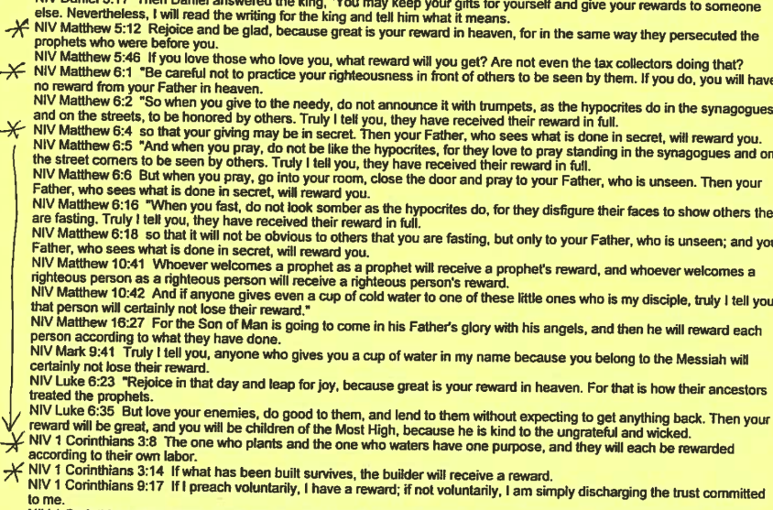
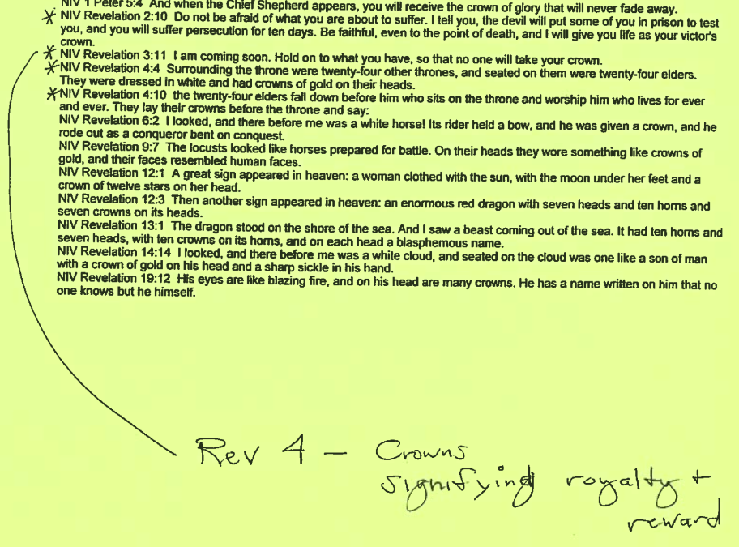

Opposing view:

Your Identity in the Trinity: Discovering God’s Grace in the ...
The author, Sean Cole, inadvertently (?) quoted one-time CRC minister, Louis Berkhof’s “present reality in the hearts of believers.” Also doesn’t John 18:26 final sentence say “now”?
