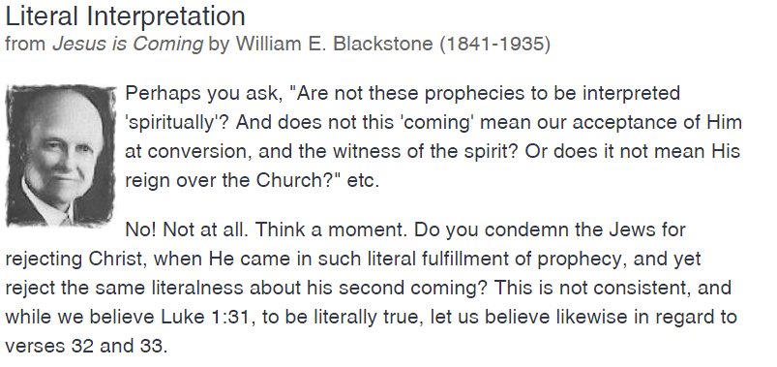
…
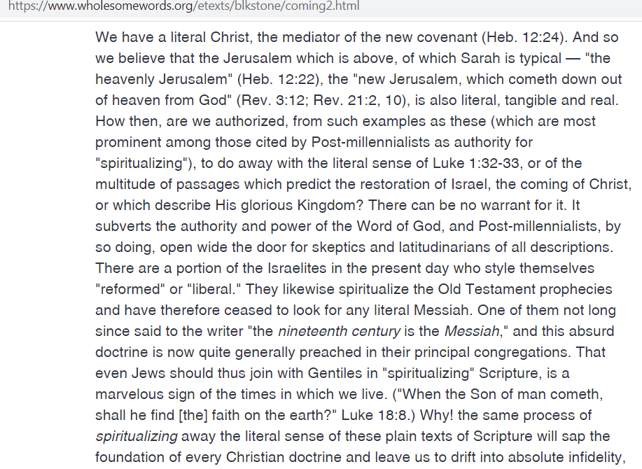
Why! the same process of spiritualizing away the literal sense of these plain texts of Scripture will sap the foundation of every Christian doctrine and leave us to drift into absolute infidelity …

>> More Jesus is Coming from source: https://www.wholesomewords.org/etexts/blkstone/coming0.html
Later in the paper it tells what the 1918 CRC thought about Blackstone’s theology in his book – it was “twisting Scriptures.” (Search for that phrase).

I’m almost picturing a debate; maybe today’s CRC would give the opposing side an opportunity to present their thoughts and Biblical interpretations? (Oh sure.)

