Some great research on the early history of the family of my ancestors was published in 1907!
I found it in my usual way = an internet search of key words. Here is part of their family tree:
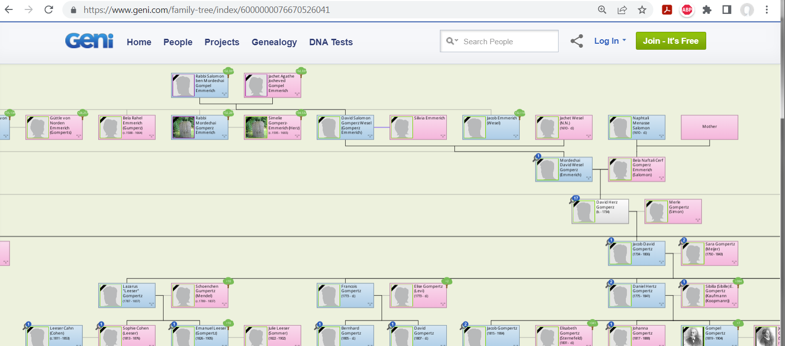

“The Gomperz Family” said they were wealthy bank lenders and “court Jews” who eventually moved from northern German cities/provinces to the Netherlands, and then … well, that is a different story!

The publication of this work could only be achieved by the
dedicated willingness to make sacrifices on the part of someone called to this
are not possible when faced with the difficult task
Shrank back, the work that had long since begun
to bring those who died early to a happy ending.

It's already been two decades since my unforgettable
Son-in-law, Professor David Kaufmann, his favorite idea
wanted to write our family history, which was one for him
rich area of ​​​​scientific research. So what
his heart needs to see those outstanding figures of ours
Ancestors whose importance stands out far beyond the crowd
raised to bring us spiritually closer and the bond related-
to establish stronger bonds of social solidarity.

He now began with his usual diligence and tireless
Eager to collect the building blocks together to help so many un-
transient merits of pure human love, unshakable
Faithfulness and heroic sacrifice are a lasting monument
to build.

On how many foreign paths, at how many distant sources
he sought and created to emerge from the stream of lost times
to unravel the tangled threads and put them together! How
often his weary foot rested on ruined burial mounds of rubble
and rubble covered to make stones talk! Him, that
Knowledgeable people, with a clear, retrospective look into it
Darkly lost centuries, it didn't remain hidden where that
real gold of historical truth was to be mined. Him what ...

who bestowed heavenly grace on the great dead of our people,
who wait for their Redeemer, from eternal slumber anew
To be able to bring them to life, to bring them out of the night of oblivion
to resurrect the radiant light of the day.
...
Budapest, July 1907.

Rosa Gomperz.

And here is another introduction to the translated book by a member of the Gomperz family;
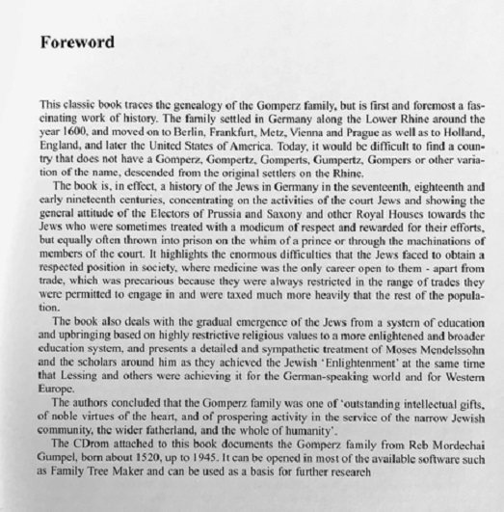
"... the Gomperz family was one of 'outstanding intellectual gifts, of noble virtues of the heart, and of prospering activity in the service of the narrow Jewish community, the wider fatherland, and the whole of humanity.'"

https://www.amazon.com/gp/customer-reviews/RT1ORSXASJIYL/ref=cm_cr_dp_d_rvw_btm?ie=UTF8&ASIN=095311046X#wasThisHelpful%20Ellyn%20Barmen
t traces the history of my mother's family back to an ancestor born perhaps in 1550 and includes my grandfather who was born in 1879. My mother saw "the book" only once as a child and believed that all extant copies were burned by the Nazis. She managed to locate and get a photocopy of some of the pages from the Leo Baeck Institute's surviving copy in the 1970's. It is written in difficult German in Gothic script. The book itself is a very careful history of the Gomperz, Gumpertz, Gompers, Gumpert, and many other variously written branches, all related. The print type is legible and from the passages I have compared closely with the original, it's a fine translation.

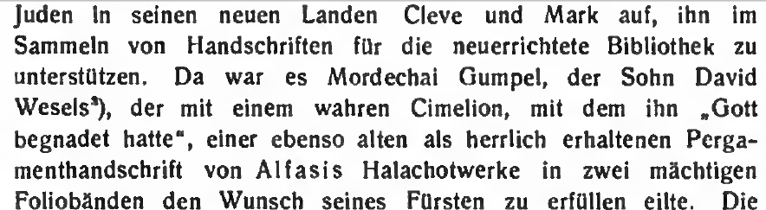
“… [In 1661 and after] It was Mordechai [or Markus] Gumpel, the son of David Wesels, who hastened to fulfill his prince's wish [= the Great Elector Friedrich Wilhelm ] with [his donation of] a true Cimelion [ancient manuscript], of Alfasi's halachot work, of whom he said “God had graced” [with?], a parchment manuscript in two old and beautifully preserved volumes.” Hmm ... I wonder if they may still exist. “On May 1, 1661, the Great Elector renewed his [uncle = Jakob Gomperz] protection right for 15 more years, also with express recognition of his previous good behavior. His brother David also had his own escort…”

Similarly, from an article about those times, link is in the end notes of my paper; “Frederick’s personal views on Jews in no way inhibited dialogue and collaboration with individual Jews. [When his son became] The king [he = Frederick The Great] wrote to the Jew Lion Gomperz saying he enjoyed the latter’s critique of the German language. Frederick had also granted the famous Jewish intellectual Moses Mendelssohn the status of a ‘Protected Jew,’ giving him right of residence in his realm.”

Sorkin’s Moses Mendelssohn and the Religious Enlightenment has more, with an interesting mention of the “’Andalusian’ tradition in medieval Jewish thought” which “aimed to create a pious … rationalism.”

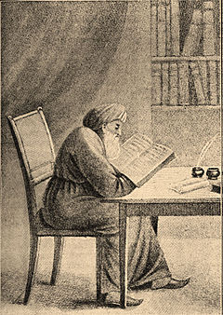 Isaac ben Jacob Alfasi
DOB = 1013 in present day Algeria – DOD = 1103 in Andalusia.
There is more to his story, and I can’t do it justice here, but you
can see that one aspect of it is the Spanish Jew = a Sephardic origin
(vs. the German Jewish = Ashkenazi background of the “court Jews”
Gomperz of Cleves family.)

Alfasi was a “Talmudic scholar who wrote a codification of the Talmud known as Sefer ha-Halakhot (“Book of Laws”), which ranks with the great codes of Maimonides…” Per https://www.britannica.com/biography/Isaac-ben-Jacob-Alfasi
(Per more from Wikipedia): Maimonides (an important historical Rabbi not very long afterwards) wrote that Alfasi's work "contains all the decisions and laws which we need in our day…".
The “Sefer ha-Halachot [a codex] plays a fundamental role in the development of Halakha.
[= Hebrew Law]” –Wikipedia. A different copy of it:
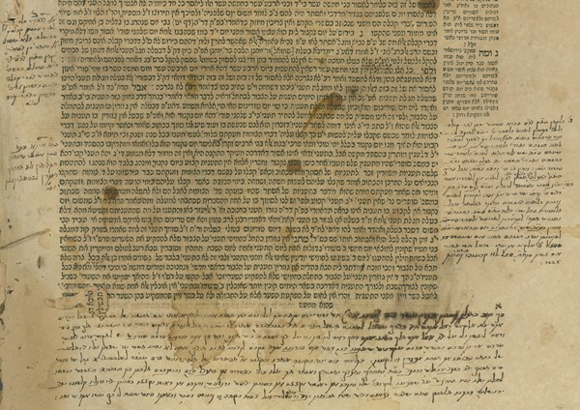

Dear Mr. Fles,

Thank you for your mail.
I am not sure I understand your request correctly - are you looking for Gumperz's edition of Alfasi's book? If so, I couldn't find it in our collections or in the collections of the National Library of Israel. Perhaps the Jewish Theological Institute (JTS) would have more information about such manuscripts.

Best Regards,
Dr. Meirav Reuveny
Archive Manager (she/her)
Leo Baeck Institute Jerusalem
I

