"Handelingen van de synode der Christelijke Gereformeerde kerk in Nederland gehouden van 5 tot 20 Junij 1872, te Groningen . -". S. van Velzen Jr.1872. Geraadpleegd op Delpher op 04-04-2022, https://resolver.kb.nl/resolve?urn=MMUBVU02:000009990:00005
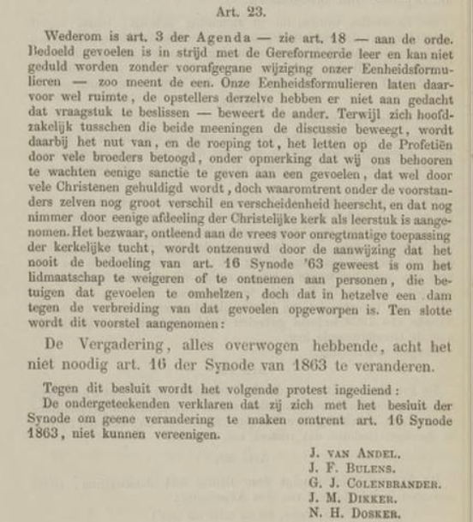 4 were from Gelderland, all but Dosker. The mission of Brother C. de Best came up;
“… in view of the good testimonies given by the said brother, must remove any objection to his appeal. The Assembly unanimously decides: to comply with Gelderland's request.”
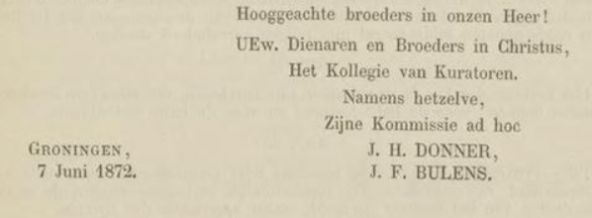 J. H. Donner was at this one. Did he change his stance?

Again, art. 3 of the Agenda — see art. 18 — under discussion. This feeling is contrary to the Reformed doctrine and cannot be tolerated without prior modification of our Unit Forms — so one thinks. Our Unit Forms leave room for this, the authors of them have not thought of deciding that question — asserts the other. While the discussion moves chiefly between these two opinions, the utility of, and the call to, heeding the Prophecies is argued by many brethren, remarking that we ought to beware of giving any sanction to a feeling that is honored by many Christians, but about which there is still great difference and diversity among the proponents themselves, and which has never been accepted as a doctrine by any division of the Christian church. The objection, based on the fear of unlawful application of ecclesiastical discipline, is refuted by the indication that it is never the intention of art. 16 Synod '63 has been to refuse or remove membership from persons who profess to embrace that feeling, but that in the same a dam has been erected against the spread of that feeling. Finally, this proposal is adopted:

The Assembly, having considered everything, does not consider it necessary art. 1 (5 of the Synod of 1863 to be changed.

The following protest is lodged against this decision:

The undersigned declare that they agree with the decision of the Synod not to make any changes with regard to art. 16 Synod 1863, [although they remain] unable to unite [with the rest].

J. van Andel.
J.F. Bulens.
G.J. Colenbrander.
J.M. Dikker.
N.H. Dosker (who preached at a church in Harlingen, Friesland at that time. He -and Henry- immigrated to Grand Rapids in 1873. I wonder…)

